Docker Installation was successful

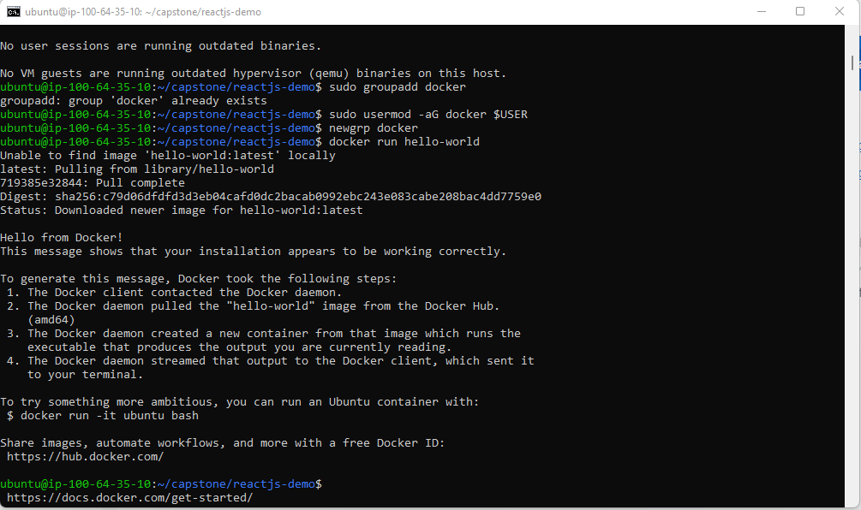

Dockerfile was created and docker build completed

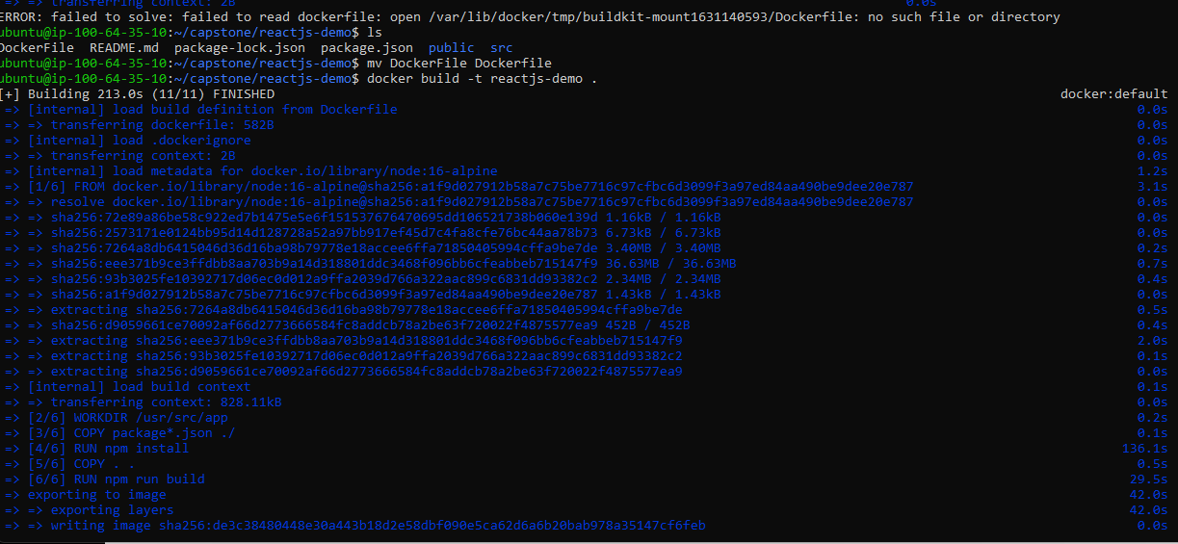

Docker image created

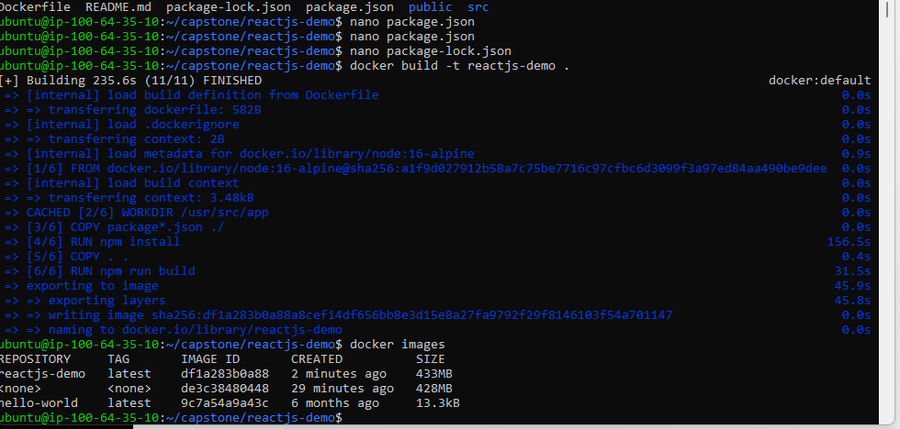

Container is UP and running using Docker run and docker-compose up commands

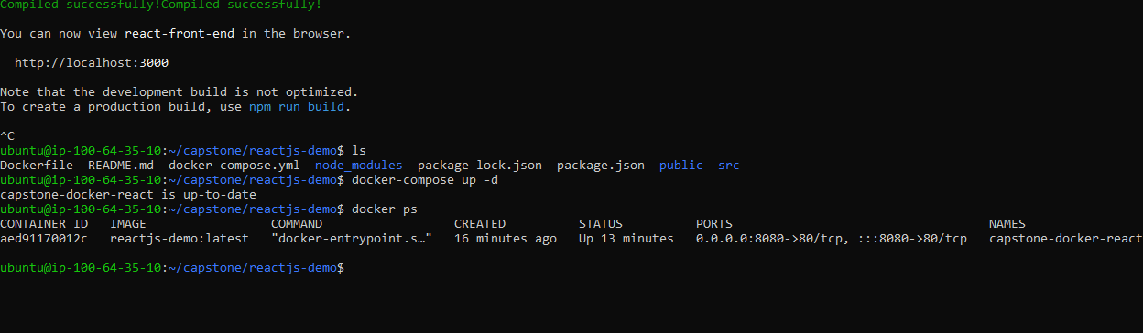

Building Docker image using Bash Scripts

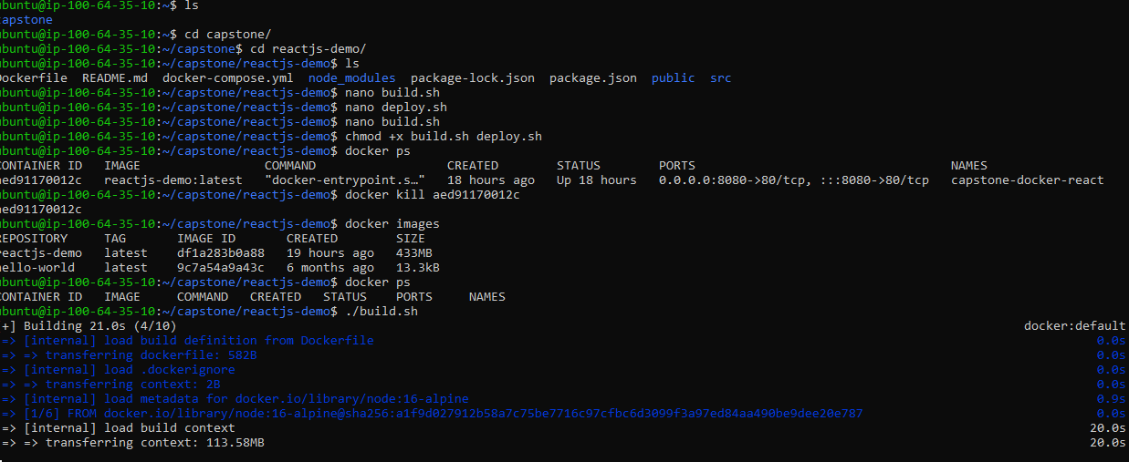

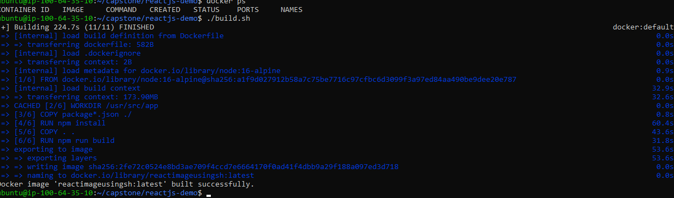

Image available after building it successfully

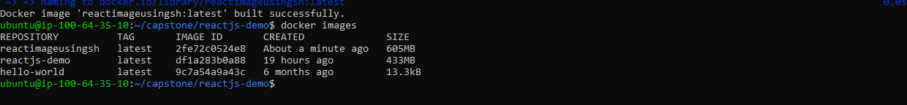

Container running after running Deploy script running docker-compose

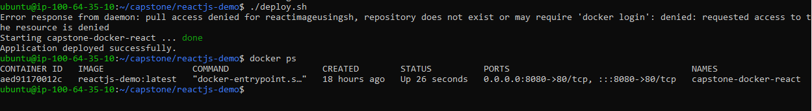

Git Repo Commands

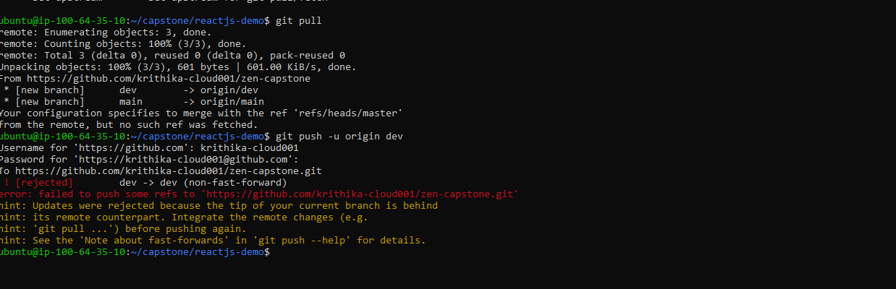

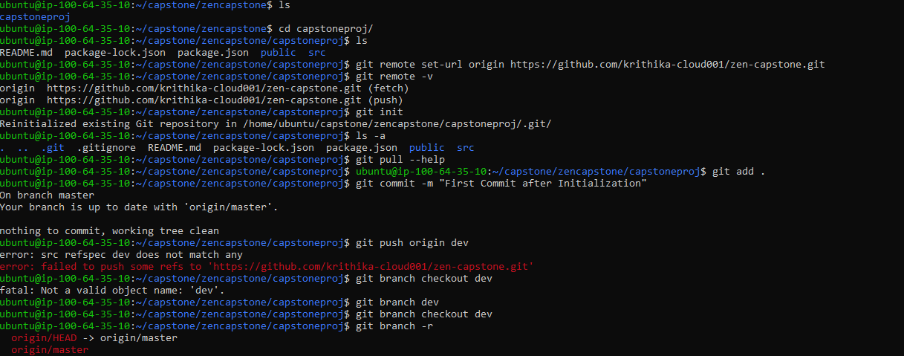

Git push all files onto Dev branch of Repository

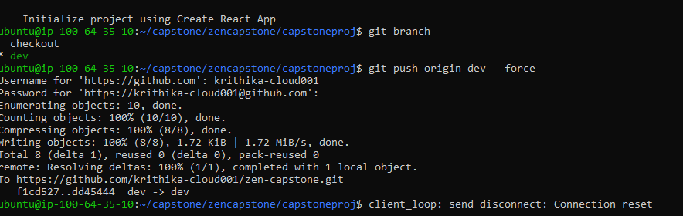

All files committed available in Git

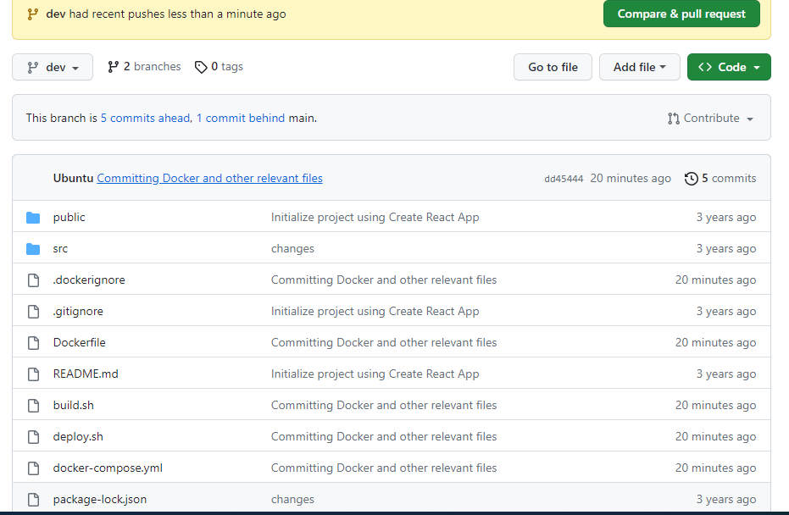

Pushing Image to Docker Hub

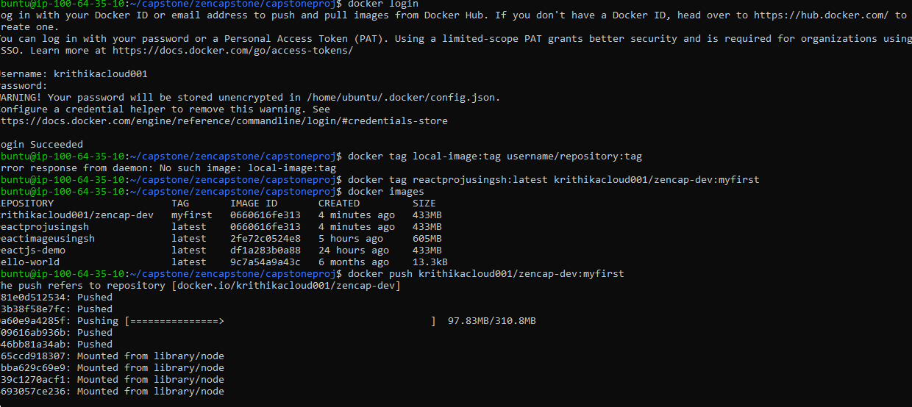

Docker Image pushed to Repository

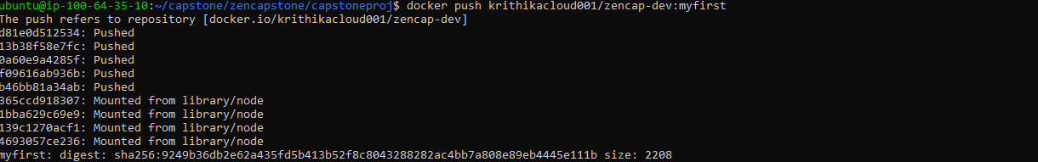

In Docker Hub Dev Repo

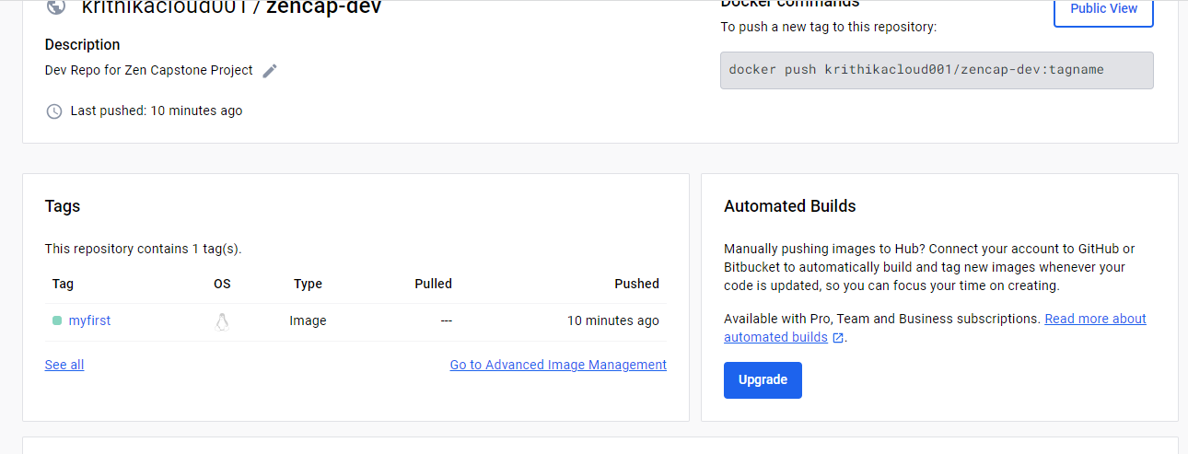

Jenkins Installation

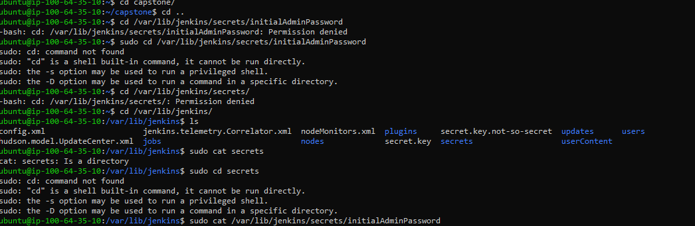

Jenkins Build run when Dev branch has a push and the image is uploaded to Docker Dev Repo

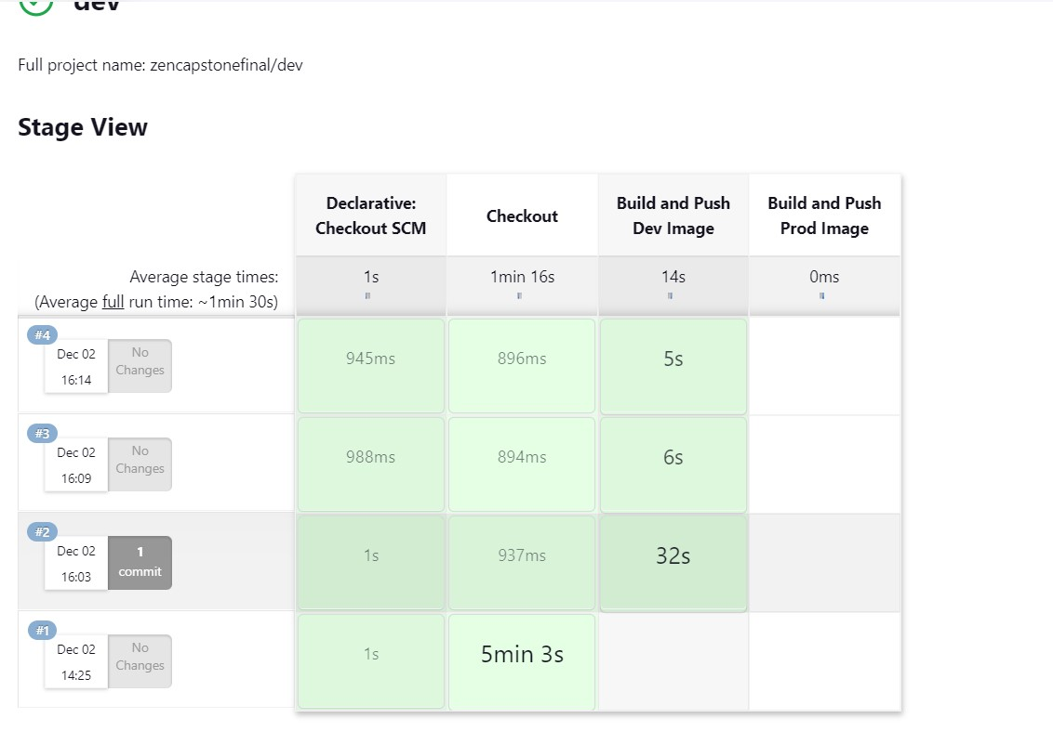

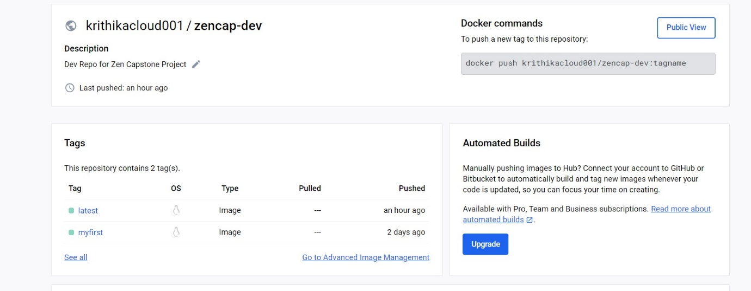

Jenkins Build run when main branch has a push and the image is uploaded to Docker prod Repo

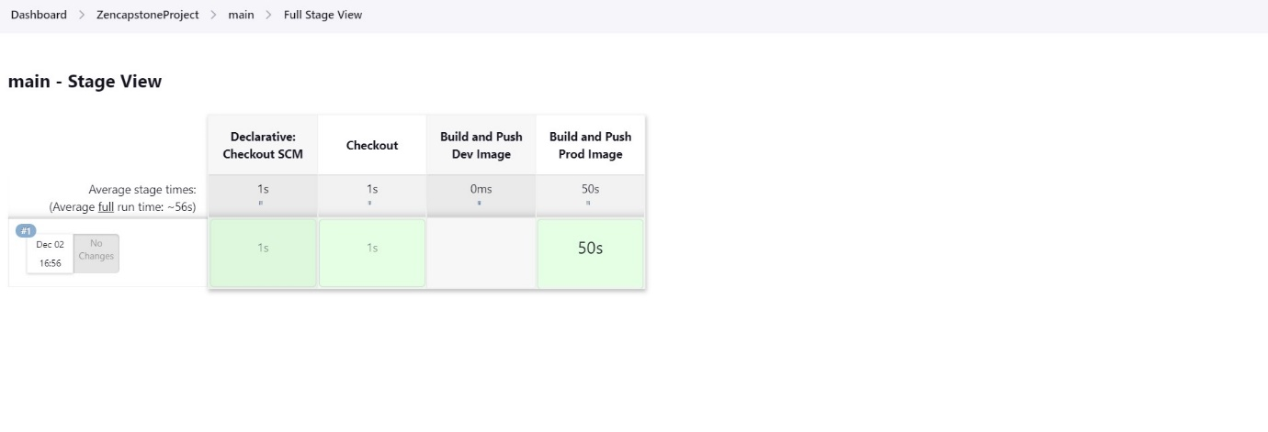

Docker PROD Repo

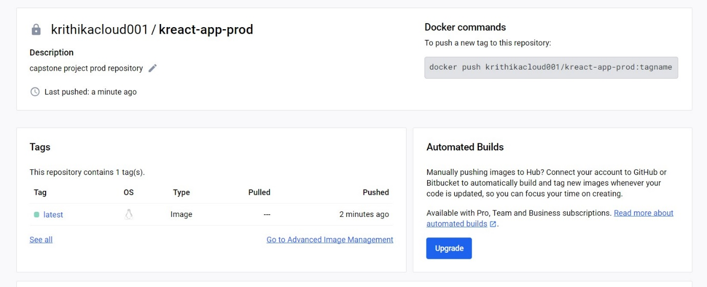

AWS EC2 Instance deployed



Note: The instance was changed to t3a.medium from t2.micro because Jenkins could not run on it.

SG implementation

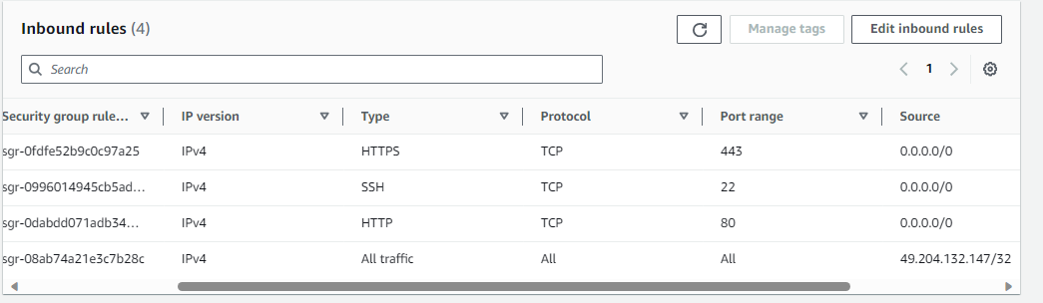

Accessing application hosted on EC2 instance

